SUPPLY LIST and Summer Reading FOR GRADE 6
Math: 2 inch binder, 5 dividers, graphing notebook (3 hole punched) or graph paper (3 hole punched), highlighters and index cards. Essentials include sufficient writing utensils, erasers, pencil sharpener and a ruler. Also a light three hold punch tool. Example copied from Amazon but widely available, light enough to fit in binder.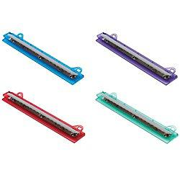

ELA Supplies: A composition notebook, -2 Folders, – 1-inch binder, index cards

Religion: 1 inch binder, loose leaf paper

Science: composition notebook (journal), 1 two sided folder

Social Studies: 1 composition notebook, 1 folder

Essentials: colored pencils, pencils, pens, ruler, eraser, glue stick, pencil sharpener

Miscellaneous Classroom Supplies
copy paper
paper towels
tissues
wipes

REQUIRED READING: The Watsons Go to Birmingham by Christopher Paul Curtis. Each student MUST bring a copy of the book back to school in September. We will study and discuss the book at that time and students will be assigned activities and an assessment based on the book.
Grade 6 also suggests they read a biography and/or a historical fiction book. Minimum of AT LEAST 3 books.
Summer Math: as many of the students are enrolled in an ISEE prep. course there is no mandatory math assignment for the summer. If you wish extra independent practice, I suggest you purchase the following workbook:
Spectrum Math 5: focused practice for math mastery
If you believe your child would prefer the challenge of grade 6 practice problems, the grade 6 version of this book is also displayed.
Spectrum Math 6: focused practice for math mastery

