Christmas Enchanted Village Project
Monday 16th December is the latest new deadline if we hope to invite the younger students to see our Enchanted Village of ChristMath
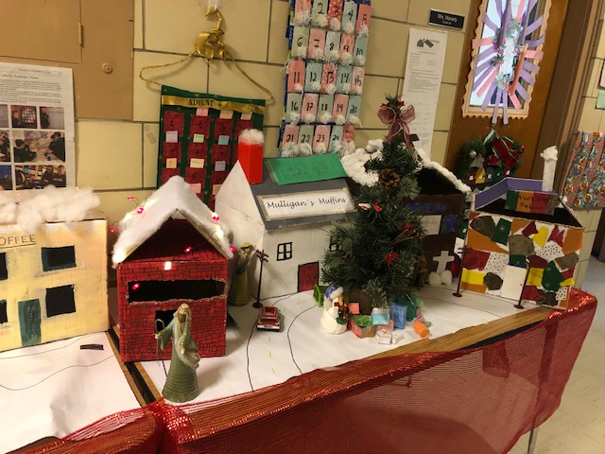
Due date: December 11th
Extended to December 12th to display for Christmas concert if possibleIn school time provided:

Monday November 25th: 12:20 – 1:40
Tuesday November 26th: 1:00 – 1:40 6A only
Wednesday November 27th 8:30 – 9:30
Monday December 2nd 9:20 – 10:00
Monday December 2nd 1:40 – 2:20 6B only
Tuesday December 3rd 1:00 – 1:40 6A only
Wednesday December 4th 1:00 – 1:40 6B only
No additional in school time allowed due to Nativity Christmas service practices

Structure
Create a house (or other building in a village) to meet the following criteria;
- The volume of the structure (excluding the roof) measures somewhere between 20,000cm³ and 50,000cm³
- The main structure is a rectangular prism, constructed from a strong plain paper bag or similar materials such as a box.
- The structure is aesthetically and/or creatively decorated
- Minimum requirements: main front door and two front windows
- Roof: front and back, sides not required (but may include). Roof can be any shape that you are confident working with: for example; triangular or rectangular or any quadrilateral shape including trapezoid.
- At least one additional feature (extra window, awning, chimney, window box, porch etc.) is included
- Attach the following page to a side of the house

My Name_____________________ My Structure _____________________

Calculations (attach additional pages as required. If work is not shown, assumption is that calculator used and therefore zero credit for that section)
Dimensions of rectangular prism (excluding roof) | Length = ________  Width = ________  Height = ________ | Total volume =
The area of the roof (front and back only) | Area = | My work:
The cost of a new roof (front and back only) at $0.20 per square cm | Cost of new roof = | My work:
Walking around my structure, I calculate the perimeter to = | Perimeter = | My work:
The front of your building needs to be painted in the Spring. | Calculate the surface area excluding windows and doors as: ____________cm² | Calculate the cost of the paint project if the painter is charging 25c per cm²
I added the following improvement to my structure: _____________ | My additional structure measures ______ cm². The contractor estimates that is will take ____ hours to build. | The contractor charges $40 per hour and $9 per square cm for materials. How much did it cost to add this improvement to your building?

