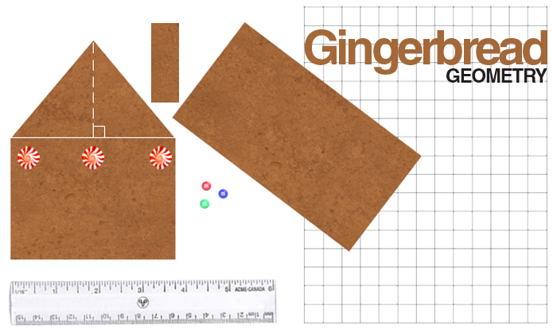
Christmas Enchanted Village Project
Due date: December 12th
In school time provided:

Tuesday November 27th 1:00 – 1:40
Wednesday November 28th 1:40 – 2:20
Thursday November 29th 8:30 – 9:15
Monday December 3rd 8:40 – 9:20
Tuesday December 4th 12:50 – 1:40
Thursday December 6th 8:30 – 9:15
Tuesday December 11th 1:00 – 1:40

Structure
Create a house (or other building in a village) to meet the following criteria;
- The volume of the structure (excluding the roof) measures somewhere between 20,000cm³ and 50,000cm³
- The main structure is a rectangular prism, constructed from a strong plain paper bag or similar materials.
- The structure is aesthetically and/or creatively decorated
- Minimum requirements: main front door and two front windows
- Roof: front and back, sides not required (but may include). Roof can be any shape that you are confident working with: for example; triangular or rectangular or any quadrilateral shape including trapezoid.
- At least one additional feature (extra window, chimney, window box, porch etc.) is included
- Attach the following page to a side of the house

My Name_____________________ My Structure _____________________

Calculations

Dimensions of rectangular prism | Length = ________  Width = ________  Height = ________ | Total volume =
The area of the roof (front and back only) | Area = | My work:
The cost of a new roof (front and back only) at $0.20 per square cm | Cost of new roof = | My work:
Walking around my structure, I calculate the perimeter to = | Perimeter = | My work:
The front of your building needs to be painted in the Spring. | Calculate the surface area excluding windows and doors as: ____________cm² | Calculate the cost of the paint project if the painter is charging 25c per cm²
I added the following improvement to my structure: _____________ | The dimensions are: | Calculate the volume (if 3 dimensional) or area (if 2 dimensional) of your addition

